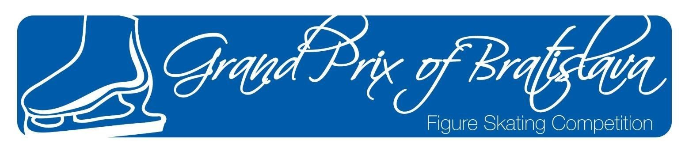

ANNOUNCEMENT / INVITATION
61st GRAND PRIX of BRATISLAVA

An Interclub

Juvenille and Pre-Juvenille Competition Boys, Girls, Adult, Hobby
organized by the

Figure Skating Club Slovan Bratislava

December 13 – 15, 2019
in Bratislava, Slovakia

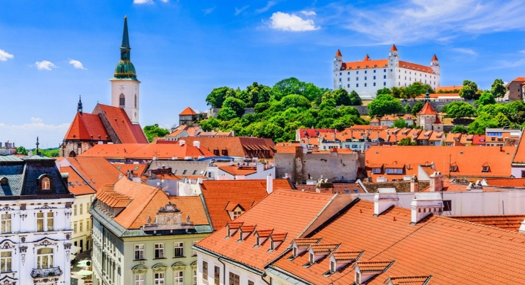

1. GENERAL

The 61st Grand Prix of Bratislava will be conducted in accordance with the ISU Constitution and General Regulations 2018, the Special Regulations & Technical Rules Single & Pair Skating and Ice Dance 2018, and the relevant ISU Communications.

Participation in the 61st Grand Prix of Bratislava is open to all Competitors who belong to an ISU Member, and qualify with regard to eligibility according to Rule 102, provided their ages fall within the limits specified in Rule 108, paragraph 3 a) and they meet the participation, citizenship and residency requirements in Rule 109, paragraphs 1 through 5 and ISU Communication 2030 or any update of this Communication.

In accordance with Rule 109 of the ISU General Regulations and ISU Communication 2030 all Skaters who do not have the nationality of the Member by which they have been entered or who, although having such nationality, have in the past represented another Member, must produce an ISU Clearance Certificate. Passports of all Skaters, as well as the ISU Clearance Certificate, if applicable, must to be presented at the accreditation of the event for verification.

All competitors must be entered through their respective Member Federation.
The winners of every category will receive the medals and diplomas. All competitors will receive diplomas.
2. TECHNICAL DATA

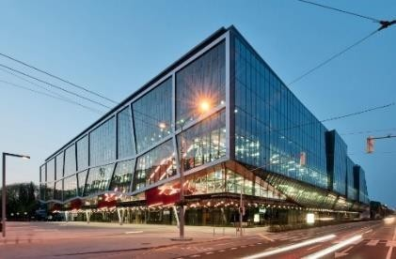
ISU Member: Slovak Figure Skating Association

Place: Ondrej Nepela Ice Rink Hall B (58 m x 28 m)
a skating complex with three indoor ice-rinks,
air conditioned and heated with the ice surface of 58m x 28m and Hall A practice 56m x 26m; the rinks are next to each other. Odbojárov 1, Bratislava

JUVENILE GIRLS 10 (BORN AFTER 1ST JULY 2009 – 30TH JUNE 2010)

JUVENILE GIRLS 9 (BORN AFTER 1ST JULY 2010 – 30TH JUNE 2011)

JUVENILE BOYS (BORN AFTER 1ST JULY 2009 – 30TH JUNE 2011)

FREE SKATING
Duration: 2 min., 30 sec. +/- 10 sec

Vocal music is allowed.
A well balanced Free Skating program for Juvenile must contain:
- Maximum of 5 jump elements for Girls and Boys one of which must be an Axel type jump. There may be up to two (2) jump combinations or sequences. A jump combination can contain only two (2) jumps. A jump sequence can contain any number of jumps, but only two most difficult jumps will be counted. Any single and double jump (including Double Axel) cannot be executed more than twice in total. Repeated jump must be executed eighter in a jump combination or in a jump sequence. Each repeated solo jump, which is not part of the combination or sequence, is evalueted with the 70 % of its original base value and will be marked as jump + REP.
- There must be a maximum of two (2) spins of a different nature (abbreviation), one of which must be a spin combination and one must be a spin with no change of position. The spin combination can be executed with a change of foot and a minimum of eight (8) revolutions or without a change of foot with a minimum of six (6) revolutions. The spin with no change of position can be executed with a change of foot and a minimum of eight (8) revolutions or without a change of foot and a minimum of six (6) revolutions. In both spins flying entries are allowed.
- There must be a maximum of one (1) step sequence or one (1) choreographic sequence. Step sequence will be subject to levels. The step sequence must fully utilize 2/3 of an ice surface. Choreographic sequence must fully utilize 2/3 of an ice surface and must contain at least one (1) spiral position of min. 3 sec. and there might be any kind of movements like steps, turns, spirals, arabesques, spread eagles, Ina Bauers, hydroblading, transitional (unlisted) jumps, spinning movements etc. The Choreographic Sequence has a base value and will be evaluated by the judges in GOE only.
Levels explanations:
For Juvenile, in all elements which are subject to Levels, only features up to Level 3 will be counted. Any additional features will not count for Level requirements and will be ignored by the Technical Panel.
The Program Components are only judged in:  - Skating Skills  - Performance/Execution  - Interpretation  The Factors of the Program Components are:  - for boys 2.0  - for girls 1.7 | Deduction  - For time -1.0 for every missing or 5 seconds more,  - Illegal elements -2.0,  - For costume and accessories -1.0,  - Fall -0.5 - For interruption (every 10 seconds more) -0,5  - For interruption (up to 3 minutes) -2,5

PRE-JUVENILE GIRLS 8 (BORN AFTER 1ST JULY 2011 – 30TH JUNE 2012)

PRE-JUVENILE GIRLS 7 (BORN AFTER 1ST JULY 2012 – 30TH JUNE 2013)

PRE-JUVENILE BOYS (BORN AFTER 1ST JULY 2011 – 30TH JUNE 2013)

FREE SKATING
Duration: 2 min. +/- 10 sec

Vocal music is allowed.
A well balanced Free Skating program for Juvenile must contain:
- Maximum of 4 jump elements for Girls and Boys. There may be up to two (2) jump combinations or sequences. Jump combinations can contain only two (2) jumps. A jump sequence can contain any number of jumps, but only two most difficult jumps will be counted. Triple jumps are not permitted. Any single and double jump cannot be executed more than twice in total. Repeated jump must be executed eighter in a jump combination or in a jump sequence. Each repeated solo jump, which is not part of the combination or sequence, is evalueted with the 70 % of its original base value and will be marked as jump + REP.
- There must be a maximum of two (2) spins of a different nature (abbreviation). The spin can be executed with a change of foot and a minimum of six (6) revolutions or without a change of foot and a minimum of four (4) revolutions.
- There must be a maximum of one (1) Choreographic Sequence that will be counted with base value. A choreographic Sequence has to consist of min. one (1) spiral position with min. 3 sec. and there might be any kind of movements like steps, turns, spirals, arabesques, spread eagles, Ina Bauers, hydroblading, transitional (unlisted) jumps, spinning movements etc. The pattern is not restricted, but the Sequence must fully utilize min. the 2/3 of ice surface. If this requirement is not fulfilled, the Sequence will have no value. The Choreographic Sequence has a base value and will be evaluated by the judges in GOE only.
Levels explanations:
For Pre-Juvenile, in all elements which are subject to Levels, only features up to Level 2 will be counted. Any additional features will not count for Level requirements and will be ignored by the Technical Panel (but can increase the GOE from judges).
The Program Components are only judged in:  - Skating Skills  - Performance/Execution  The Factors of the Program Components are  - 2.5 for boys and girls.  Bonus for 2A and every different triple jump: +1,0 | Deductions:  - For time -1.0 for every missing or 5 seconds more,  - Illegal elements -2.0,  - For costume and accessories -1.0,  - Fall -0.5  - For interruption (every 10 seconds more) -0,5  - For interruption (up to 3 minutes) -2,5

Interclub Competitions in Slovak Announcement:

Hobby Silver younger 1.7.2007 – 30.6.2009
Hobby Silver older 1.7.2004 – 30.6.2007
Hobby Silver junior 1.7.2000 – 30.6.2004
Adult Silver born to 30.6.2000

Podľa pravidiel SKRZ 2/2018 z 19.5.2018

3. ENTRIES of COMPETITORS

ISU Members must enter their competitors/couples and their substitutes on the official forms:

Entry Form for Competitors

Entries must be confirmed by e-mail and sent to the Organizers and Slovak Figure Skating Association.

Each ISU Member has the right to nominate two competitors for each single event in the Grand Prix of Bratislava 2019.
List of entries (competitors, judges, team leaders, coaches, other persons) must reach the organizer
by November 20th, 2019 at the following address:

FSC Slovan Bratislava Ružinovská 4
82101 Bratislava
e-mail: GPBratislava@gmail.com ;
director : | Maria Hrachovcova | +421 918 643 610
head of OC: | Zuzana Jánošová | +421 907 265 462
Economy manager: | Pavla Mauerova | +421 905 342 311
assistent of head of OC: | Martin Rinco | +421 902 946 944

It is mandatory that the form "Planned Program Content Sheet" must be filled in for each skater of each category in English using the terminology for the elements listed in the respective ISU Communication. This form must reach the organizer at latest November 20th 2019

It is not permitted to hand over the Program Content Sheets directly to the acting Officials.
4. ENTRIES of JUDGES

Each ISU Member has the right to enter one judge with the qualification “Judge for International competitions” or “ISU Judge”. If an ISU Member has entries in three or more disciplines, this Member has the right to enter a second judge, who has to have the qualification “ISU Judge for Ice Dance” AND if possible also “ISU Judge for
Single and Pair Skating”.

The organizer reserves the right to draw for the composition of panels beforehand and inform those judges who are not drawn for service.
5. ENTRIES of TEAM OFFICIALS

Official entries of Team Leaders, Team Officials, Coaches/Choreographers, Team Medical staff etc. must be made together with the entries for Competitors and Judges. The names of such Team Officials must be listed on the official Form “Composition of Delegation”. Judges and Judges’ partners are to be listed on the separate Form “Judges Entry”.

6. ENTRY DEADLINE

The Organizing Committee requests the Preliminary Entry Forms to be returned to the below mentioned address by November 10th, 2019.

Entries for Competitors and Judges must reach the organizer latest by

November 20th, 2019

The Forms Preliminary Entry, Composition of Delegation, Competitor Entry, Judges Entry and Hotel Sheet have to be used and must be sent to:

Slovak Figure Skating Association

Email: slovakskating@kraso.sk

Figure Skating Club Slovan
Mobile: 00421 907265462; 00421 918643610

Email: GPBratislava@gmail.com

All other forms must reach the Organizing Committee FSC Slovan Bratislava also by

November 15th, 2019

An overview of all Forms is provided in chapter 16 of this announcement. Please find all Forms in electronic version on the following website: www.gpba.weebly.com .
The starting order after the draw will be available on the same website no later than 6th of December 2019.

7. MUSIC

All competitors shall furnish competition music of excellent quality on either CD and USB key (Compact Discs) format or any other electronic means. The discs must show the exact running time of the music (not skating time), which shall be certified by the competitor and by the coach, when submitted at the time of registration. Each program must be recorded on a separate disk. Competitors must provide a back-up drive for each program.

The titles, composers and orchestras of the music to be used for the Short Program and Free Skating Program for Singles and Pairs, for the Short and Free Dance Program for Ice Dance must be listed for each Competitor on the official Music Selection Form and attached to the official Entry Form for Competitors.

If music information is not complete and music not provided, accreditation will not be given.

8. EXPENSES PROVIDED

The organizer will provide accommodation and meals for all Referees, Judges drawn for the panel Technical Controllers, Technical Specialists, Data/Video Operators.

Competitors and all other Team Members have to bear their own expenses.
All Competitors, Coaches and Team Leaders have to bear their own expenses. Hotel accommodation can be booked only through the organiser. The prices are agreed exclusively with the organiser. Please send your booking at the attached form to GPBratislava@gmail.com, slovan.kraso@gmail.com not latest by 15th of November 2019

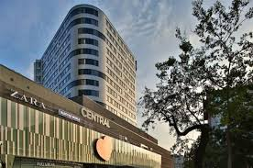
LINDNER Hotel Gallery Central Bratislava ****
Metodova 4
821 08 Bratislava

Distance from the Ice rink – 300 m
Prices for accommodation (breakfast included)/per day
Single room – business class 85 € Double room – business class 95 €

Municipality taxes included in price of room

The Organizer can guarantee and provide you accommodation only after receiving 100% of total payment for accommodation (cancellation fee included) before 20th of November 2019 on the following bank account.

Bank: J&T Banka, Bratislava, Slovakia
Adress: Dvořákovo nábr. 9,
81102 Bratislava
IBAN: SK65 8320 0000 0012 0009 0818
SWIFT/BIC: JTBPSKBA
Account no. 1200090818
Bank code 8320

Travel expenses will be paid only to the Referees, the Technical Specialists, the Technical Controllers and Data/Video Operators based on economy airfare. All extra expenses incurred by any Official will be the responsibility of the respective person and must be paid prior to the departure. The Airport is “Airport Bratislava” which is about 15 minutes far from official hotel and Ice Rink. The railway Station is “Bratislava Railway Station” or „Bratislava Bus Station –
Mlynske Nivy“
The Organizing Committee provides a shuttle bus upon arrival and departure for the teams at the airport. Transportation fee of EUR 15,- /one person/one way will be asked and should be paid at the registrations. Transportation fee of EUR 30,- / one person/one way – Airport Swechat Wien Austria
9. CHARGES

ENTRY FEE:
Bank: J&T Banka, Bratislava, Slovakia
Adress: Dvořákovo nábr. 9,
81102 Bratislava
IBAN: SK65 8320 0000 0012 0009 0818
SWIFT/BIC: JTBPSKBA
Account no. 1200090818
Bank code 8320
EUR 65/ skater Juniors and Novices EUR 85/ couple Ice Dance

EUR 45/ skater

This fee has to be paid
Other categories
with entries to account of Organizer before draw.
To 20th November 2019
We don´t return entries fee.

10. LIABILITY

In accordance with Rule 119, it is the sole responsibility of each Member participating in the 61st Grand Prix of Bratislava 2019, to provide medical and accident insurance for their athletes, officials and all other members of the Member´s team. Such insurance must assure full medical attendance and also the return to the home country by air transport or by other expeditious means of the ill or injure person.

The Organizer assumes no responsibility for or liability with respect to bodily or personal injury or property damage incurred in connection incurred Competitors and Officials.
11. AWARDING
The results will be announced and the prices with diplomas will be given 30 min after each category.

12. REGISTRATION

Accreditation will be given to all Event Referees, Technical Controllers, Technical Specialists, Data and Replay Operators, ISU Office Holders and Guests, all entered Judges, Competitors, one Team Leader, Team Medical staff (max. one medical doctor and one physiotherapist) - and one Coach per skater. Not more than 2 Officials of each ISU Member will also receive an accreditation provided they are Council Members of their National Federation (including Presidents) or the General Secretary of the Head Office of their Federation. Each Member confirms the function of each Team Member with the official entry form “Composition of Delegation”.

Accreditation
will be given in the OC in the Ice Rink Bratislava (Welcome Desk) from 12.12.2019 from 17,00 Round table will be to 1 hour after category
13. VARIOUS
Distance to the Ice-Rink: Bratislava – Bratislava Airport (5 km)

Bratislava - Vienna Airport/Schwechat (50 km) Bratislava - Brno Airport/Tuřany (130 km) Bratislava - Budapest Airport (200km)

Transportation : all Referees, Technical Panels, Judges, Participants and Coaches are requested to announce to the organizer not later than November, 20th, 2019 arrival information on the prescribed Form.

Information: the boxes for Members will be placed in the ice rink.

14. INFORMATIONS

Please address all request to:

FSC Slovan Bratislava Ružinovská 4
821 01 Bratislava SLOVAKIA

Mobile: +421 907 265 462; +421 918 643 610
Email: GPBratislava@gmail.com; slovan.kraso@gmail.com

15. PRELIMINARY EVENT SCHEDULE (subject to change)

Thursday, December 12th, 2019
Un official practices according forms

20.00 Judges meeting in the Hotel Lindner

Friday, December 13th, 2019
Official Practices hall A for Junior and Advanced Novices Girls, Boys, Ice Dance

Competition Hall B

Hobby silver younger
Hobby silver older
Hobby silver junior
Adults silver
Pre – Juvenile Girls 7 FS Pre – Juvenile Boys FS Juvenille Girls 9 - FS
Pre – Novices Girls FS Pre – Novices Boys FS
Advanced Novices Girls – SP Advanced Novices Boys – SP

Saturday, December 14th, 2019 Practices Hall A
Junior Girls
Junior Boys Junior Ice Dance
Advanced Novices Girls Advanced Novices Boys Advanced Novices Ice Dance

Competition Hall B
Juvenile Boys – FS
Basic novice Boys
Basic novice Girls
Junior Girls - SP Junior Boys – SP
Advanced Novices Ice Dance - SD Junior Ice Dance - SD
Advanced Novices Girls - FS Advanced Novices Boys – FS

Victory Ceremony for Addvances Novices non on the Ice rink
Sunday, December 15th, 2019 Practices Hall A
Junior Girls Junior Men Junior Ice Dance

Competition Hall B
Pre - Juvenile girls 8 FS Juvenile Girls 10 FS
Advanced Novices Ice Dance - FD
Junior Ice Dance - FD
Junior Girls – FS
Junior Men – FS

Victory Ceremony for Junior non on the Ice rink

16. COMPETITION ENTRY FORMS OVERVIEW

 | Form | Deadline
Form | Preliminary Entry Form | November 15th, 2019
Form | Composition of Delegation | November 20th, 2019
Form | Entry Form for Comeptitors | November 20th, 2019
Form | Entry Form for Judges | November 20th, 2019
Form | Hotel reservation request | November 20th, 2019
Form | Team Travel Form | November 20th, 2019
Form | Program Content Form | November 20th, 2019
Form | Visa form | November 20th, 2019
Form | Unofficial practices | November 20th 2019
 | Payment | November 20th, 2019

