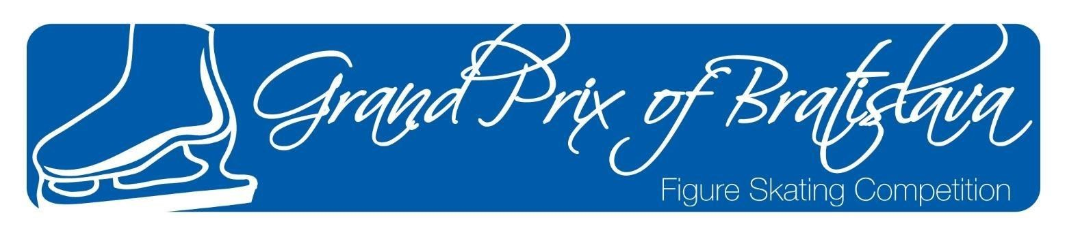

ANNOUNCEMENT / INVITATION
61st GRAND PRIX of BRATISLAVA
An International Open Competition for Junior Men, Ladies and Ice Dance
Advance Novice Boys, Girls, Ice Dance and Pre- Novice Boys and Girls and Basic
organized by the

Slovak Figure Skating Association

and Figure Skating Club Slovan Bratislava

December 13 – 15, 2019
in Bratislava, Slovakia

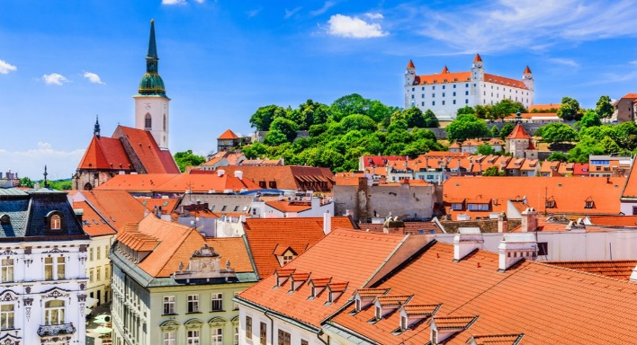

1. GENERAL

The 61st Grand Prix of Bratislava will be conducted in accordance with the ISU Constitution and General Regulations 2018, the Special Regulations & Technical Rules Single & Pair Skating and Ice Dance 2018, and the relevant ISU Communications.

Participation in the 61st Grand Prix of Bratislava is open to all Competitors who belong to an ISU Member, and qualify with regard to eligibility according to Rule 102, provided their ages fall within the limits specified in Rule 108, paragraph 3 a) and they meet the participation, citizenship and residency requirements in Rule 109, paragraphs 1 through 5 and ISU Communication 2030 or any update of this Communication.

In accordance with Rule 109 of the ISU General Regulations and ISU Communication 2030 all Skaters who do not have the nationality of the Member by which they have been entered or who, although having such nationality, have in the past represented another Member, must produce an ISU Clearance Certificate. Passports of all Skaters, as well as the ISU Clearance Certificate, if applicable, must to be presented at the accreditation of the event for verification.

All competitors must be entered through their respective Member Federation.
The winners of every category will receive the medals and diplomas. All competitors will receive diplomas.
2. TECHNICAL DATA

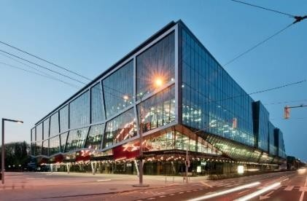
ISU Member: Slovak Figure Skating Association

Place: Ondrej Nepela Ice Rink Hall B (58 m x 28 m)
a skating complex with three indoor ice-rinks,
air conditioned and heated with the ice surface of 58m x 28m and Hall A practice 56m x 26m; the rinks are next to each other. Odbojárov 1, Bratislava

JUNIOR MEN | Short Program | The required elements to be skated are those listed in ISU Technical Rules Single & Pair Skating 2018 Rule 611, paragraphs 1 and 3 for 2019/2020.  Duration: 2 min., 40 sec +/- 10 sec.
 | Free Skating | In accordance with ISU Technical Rules Single & Pair Skating 2018, Rule 612 and the respective ISU Communication. Special attention should be paid to the “well balanced program” and the element value.  Duration: 3 min., 30 sec +/- 10 sec.
JUNIOR LADIES | Short Program | The required elements to be skated are those listed in ISU Technical Rules Single & Pair Skating 2018 Rule 611, paragraphs 1 and 3 for 2019/2020.  Duration: 2 min., 40 sec. +/- 10 sec.
 | Free Skating | In accordance with ISU Technical Rules Single & Pair Skating 2018, Rule 612 and the respective ISU Communication. Special attention should be paid to the “well balanced program” and the element value.  Duration: 3 min., 30 sec., +/- 10 sec
JUNIOR ICE DANCE | Short Dance | In accordance with ISU Technical Rules Ice Dance 2019/20, Rule 709. Rhythms, required elements and guidelines are those listed in ISU Communications 2239 and subsequent updates.  Duration: 2 min., 50 sec., +/- 10 sec
 | Free Dance | In accordance with ISU Technical Rules Ice Dance 2019/20, Rule 710. The required elements to be skated are those listed in ISU Communication 2239 and subsequent updates.  Duration: 3 min., 30 sec., +/- 10 sec.

ADV. NOVICES BOYS  Born after July 1st 2004 – June 30th 2009 | Short Program | Duration: 2 min., 20 sec. +/- 10 sec Vocal music is allowed.  The Short Program for Boys Singles shall consist of the following elements:  - Axel Paulsen or double Axel Paulsen  - Double or triple jump immediately preceded by connecting steps, may not repeat the jump in a)  - One jump combination consisting of two double jumps or one double and one triple jump, both jumps may not repeat jump in a) or b)  - Camel, sit or upright spin (min. of five (5) revolutions with change of foot and no flying entrance  - Spin combination with only one change of foot (minimum of five (5) revolutions on each foot). Flying entry is allowed.  f) One step sequence with full utilization of the ice surface.
ADV. NOVICES GIRLS  Born after July 1st 2004 – June 30th 2009 | Short program | Duration: 2 min., 20 sec. +/- 10 sec Maximum Vocal music is allowed.  The Short Program for Girls Singles shall consist of the following elements:  - Axel Paulsen or double Axel Paulsen  - Double or triple jump immediately preceded by connecting steps, may not repeat jump in a)  - One jump combination consisting of two double jumps or one double and one triple jump, both jumps may not repeat jump in a) or b)  - Layback or sideways leaning spin in one basic position with no change of foot (minimum of five (5) revolutions)  - Spin combination with only one change of foot (minimum of five (5) revolutions on each foot). Flying entry is allowed.  f) One step sequence with full utilization of the ice surface.  Jumps not according to Short Program requirements (wrong number of revolutions) will receive no value. If the same jump is executed as a solo jump and as a part of the jump combination, the repeated jump will not be counted (if this repetition is in a jump combination, only the individual jump which is not according to the above requirements will  not be counted).
ADV. NOVICES BOYS AND GIRLS | Free skating | Duration: Girls: 3 min., +/- 10 sec.  Boys: 3 min. +/- 10 sec.  A well balanced Free Skating program for Singles must contain:  a) Maximum 6 jump elements one of which must be an Axel type jump. There may be up to two (2) jump combinations or sequences. A jump combination can contain only two (2) jumps. A jump sequence can contain any number of jumps, but only two most difficult jumps will be counted. Only two (2) jumps with three (3) or more revolutions can be repeated either in a jump combination or in a jump sequence. Any single and double jump (including Double Axel) cannot be executed more than twice in total.  - There must be a maximum of two (2) spins of a different nature (abbreviation), one of which must be a spin combination with change of foot (minimum eight (8) revolutions), flying entrance is not allowed and one must be a flying spin (minimum six (6) revolutions) or a spin in one position with change of foot and a flying entrance (minimum eight (8) revolutions).  - There must be a maximum of one (1) step sequence full utilizing the ice surface.
Levels explanations:
For Advanced Novice Singles, in all elements which are subject to Levels, only features up to Level 3 will be counted. Any additional features will not count for Level requirements and will be ignored by the Technical Panel .
The Program Components are only judged in  - Skating Skills  - Transitions  - Performance/Execution  - Interpretation |  |  | The factors for the Program Components is:  Boys SP: 0.9 FS: 1.8  Girls SP: 0.8 FS: 1.6

ADVANCED NOVICES ICE DANCE | Pattern Dances | The competition comprises the Pattern Dance and the Free Dance which have to be skated according to the current ISU Rules and Regulations including the ISU Communication 2242 which are valid for the season 2019/2020.
 | Free Dance | In accordance with ISU Technical Rules Ice Dance 2019/20, Rule 710 and all pertinent ISU Communications. The required elements to be performed are those listed in ISU Communications 2239 and subsequent updates.  Duration: 3 minutes, +/- 10 sec.

PRE  NOVICES BOYS AND GIRLS  (born after 1st July 2007  – 30th June 2009) | Free Program | Duration: Girls: 3 min., +/- 10 sec.  Boys: 3 min., +/- 10 sec.  A well balanced Free Skating program for Pre-Novice boys and girls must contain:  - a) Maximum 6 jump elements for Girls and Boys one of which must be an Axel type jump. There may be up to two (2) jump combinations or sequences. A jump combination can contain only two (2) jumps. A jump sequence can contain any number of jumps, but only two most difficult jumps will be counted. Only two (2) jumps with three (3) or more revolutions can be repeated either in a jump combination or in a jump sequence. Any single and double jump (including Double Axel) cannot be executed more than twice in total.  - There must be a maximum of two (2) spins of a different nature (abbreviation), one of which must be a spin combination with change of foot (minimum eight (8) revolutions), flying entrance is not allowed and one must be a flying spin (minimum six (6) revolutions) or a spin in one position with change of foot and a flying entrance (minimum eight (8) revolutions).  - There must be a maximum of one (1) step sequence fully utilizing the ice surface
Levels explanations:
For Pre-Novice Singles, in all elements that are subject to Levels, only features up to Level 3 will be counted. Any additional features will not count for Level requirements and will be ignored by the Technical Panel
The Program Components are only judged in  - Skating Skills  - Transitions  - Performance/Execution  - Interpretation |  |  | The Factor of the Program Components is  - for boys 1.8  - for girls 1.6

BASIC  NOVICES BOYS AND GIRLS  has not reached the age of thirteen (13) | Free Program | Duration: Girls: 2:30 min, +/- 10 sec.  Boys: 2:30 min, +/- 10 sec.  A well balanced Free Skating program for Pre-Novice boys and girls must contain:  a) Maximum of 4 jump elements one of which must be an Axel type jump. There may be up to two (2) jump combinations or sequences. Jump combinations can contain only two (2) jumps. A jump sequence consists of 2 (two) jumps of any number of revolutions, beginning with any jump, immediately followed by an Axel type jump with a direct step from the landing curve of the first jump to the take-off curve of the Axel jump. No triple and quadruple jumps are allowed. Any single and double jump (including Double Axel) cannot be executed more than twice in total.  b) There must be a maximum of two (2) spins of a different nature (abbreviation), one of which must be a spin combination and one must be a spin with no change of position. The spin combination with a change of foot and a minimum of eight (8) revolutions or without a change of foot with a minimum of six (6) revolutions. The spin in one position with a change of foot  minimum of eight (8) revolutions or spin in one position without change of foot minimum of  six (6) revolutions. In both spins flying entries are allowed.  c) There must be a maximum of one (1) step sequence fully utilizing the ice surface.
Levels explanations:
For Pre-Novice Singles, in all elements that are subject to Levels, only features up to Level 2 will be counted. Any additional features will not count for Level requirements and will be ignored by the Technical Panel
The Program Components are only judged in  - Skating Skills  - Performance/Execution |  |  | The Factor of the Program Components is  - for boys 2.5  - for girls 2.5

3. ENTRIES of COMPETITORS

ISU Members must enter their competitors/couples and their substitutes on the official forms:

Entry Form for Competitors

Entries must be confirmed by e-mail and sent to the Organizers and Slovak Figure Skating Association.

Each ISU Member has the right to nominate two competitors for each single event in the Grand Prix of Bratislava 2019.
List of entries (competitors, judges, team leaders, coaches, other persons) must reach the organizer
by November 20th, 2019 at the following address:

FSC Slovan Bratislava Ružinovská 4
82101 Bratislava
e-mail: GPBratislava@gmail.com ;
director : | Maria Hrachovcova | +421 918 643 610
head of OC: | Zuzana Jánošová | +421 907 265 462
Economy manager: | Pavla Mauerova | +421 905 342 311
assistent of head of OC: | Martin Rinco | +421 902 946 944

It is mandatory that the form "Planned Program Content Sheet" must be filled in for each skater of each category in English using the terminology for the elements listed in the respective ISU Communication. This form must reach the organizer at latest November 20th 2019

It is not permitted to hand over the Program Content Sheets directly to the acting Officials.
4. ENTRIES of JUDGES

Each ISU Member has the right to enter one judge with the qualification “Judge for International competitions” or “ISU Judge”. If an ISU Member has entries in three or more disciplines, this Member has the right to enter a second judge, who has to have the qualification “ISU Judge for Ice Dance” AND if possible also “ISU Judge for
Single and Pair Skating”.

The organizer reserves the right to draw for the composition of panels beforehand and inform those judges who are not drawn for service.
5. ENTRIES of TEAM OFFICIALS

Official entries of Team Leaders, Team Officials, Coaches/Choreographers, Team Medical staff etc. must be made together with the entries for Competitors and Judges. The names of such Team Officials must be listed on the official Form “Composition of Delegation”. Judges and Judges’ partners are to be listed on the separate Form “Judges Entry”.

6. ENTRY DEADLINE

The Organizing Committee requests the Preliminary Entry Forms to be returned to the below mentioned address by November 10th, 2019.

Entries for Competitors and Judges must reach the organizer latest by

November 20th, 2019

The Forms Preliminary Entry, Composition of Delegation, Competitor Entry, Judges Entry and Hotel Sheet have to be used and must be sent to:

Slovak Figure Skating Association

Email: slovakskating@kraso.sk

Figure Skating Club Slovan
Mobile: 00421 907265462; 00421 918643610

Email: GPBratislava@gmail.com

All other forms must reach the Organizing Committee FSC Slovan Bratislava also by

November 15th, 2019

An overview of all Forms is provided in chapter 16 of this announcement. Please find all Forms in electronic version on the following website: www.gpba.weebly.com .
The starting order after the draw will be available on the same website no later than 6th of December 2019.

7. MUSIC

All competitors shall furnish competition music of excellent quality on either CD and USB key (Compact Discs) format or any other electronic means. The discs must show the exact running time of the music (not skating time), which shall be certified by the competitor and by the coach, when submitted at the time of registration. Each program must be recorded on a separate disk. Competitors must provide a back-up drive for each program.

The titles, composers and orchestras of the music to be used for the Short Program and Free Skating Program for Singles and Pairs, for the Short and Free Dance Program for Ice Dance must be listed for each Competitor on the official Music Selection Form and attached to the official Entry Form for Competitors.

If music information is not complete and music not provided, accreditation will not be given.

8. EXPENSES PROVIDED

The organizer will provide accommodation and meals for all Referees, Judges drawn for the panel Technical Controllers, Technical Specialists, Data/Video Operators.

Competitors and all other Team Members have to bear their own expenses.
All Competitors, Coaches and Team Leaders have to bear their own expenses. Hotel accommodation can be booked only through the organiser. The prices are agreed exclusively with the organiser. Please send your booking at the attached form to GPBratislava@gmail.com, slovan.kraso@gmail.com not latest by 15th of November 2019

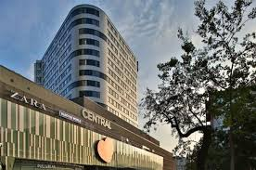
LINDNER Hotel Gallery Central Bratislava ****
Metodova 4
821 08 Bratislava

Distance from the Ice rink – 300 m
Prices for accommodation (breakfast included)/per day
Single room – business class 85 € Double room – business class 95 €

Municipality taxes included in price of room

The Organizer can guarantee and provide you accommodation only after receiving 100% of total payment for accommodation (cancellation fee included) before 20th of November 2019 on the following bank account.

Bank: J&T Banka, Bratislava, Slovakia
Adress: Dvořákovo nábr. 9,
81102 Bratislava
IBAN: SK65 8320 0000 0012 0009 0818
SWIFT/BIC: JTBPSKBA
Account no. 1200090818
Bank code 8320

Travel expenses will be paid only to the Referees, the Technical Specialists, the Technical Controllers and Data/Video Operators based on economy airfare. All extra expenses incurred by any Official will be the responsibility of the respective person and must be paid prior to the departure. The Airport is “Airport Bratislava” which is about 15 minutes far from official hotel and Ice Rink. The railway Station is “Bratislava Railway Station” or „Bratislava Bus Station –

Mlynske Nivy“
The Organizing Committee provides a shuttle bus upon arrival and departure for the teams at the airport. Transportation fee of EUR 15,- /one person/one way will be asked and should be paid at the registrations. Transportation fee of EUR 30,- / one person/one way – Airport Swechat Wien Austria

9. CHARGES

ENTRY FEE:
Bank: J&T Banka, Bratislava, Slovakia
Adress: Dvořákovo nábr. 9,
81102 Bratislava
IBAN: SK65 8320 0000 0012 0009 0818
SWIFT/BIC: JTBPSKBA
Account no. 1200090818
Bank code 8320
EUR 65/ skater Juniors and Novices EUR 85/ couple Ice Dance

EUR 45/ skater

This fee has to be paid
Other categories
with entries to account of Organizer before draw.
To 20th November 2019
We don´t return entries fee.

10. LIABILITY

In accordance with Rule 119, it is the sole responsibility of each Member participating in the 61st Grand Prix of Bratislava 2019, to provide medical and accident insurance for their athletes, officials and all other members of the Member´s team. Such insurance must assure full medical attendance and also the return to the home country by air transport or by other expeditious means of the ill or injure person.

The Organizer assumes no responsibility for or liability with respect to bodily or personal injury or property damage incurred in connection incurred Competitors and Officials.
11. AWARDING
The results will be announced and the prices with diplomas will be given 30 min after each category.

12. REGISTRATION

Accreditation will be given to all Event Referees, Technical Controllers, Technical Specialists, Data and Replay Operators, ISU Office Holders and Guests, all entered Judges, Competitors, one Team Leader, Team Medical staff (max. one medical doctor and one physiotherapist) - and one Coach per skater. Not more than 2 Officials of each ISU Member will also receive an accreditation provided they are Council Members of their National Federation (including Presidents) or the General Secretary of the Head Office of their Federation. Each Member confirms the function of each Team Member with the official entry form “Composition of Delegation”.

Accreditation
will be given in the OC in the Ice Rink Bratislava (Welcome Desk) from 12.12.2019 from 17,00 Round table will be to 1 hour after category
13. VARIOUS
Distance to the Ice-Rink: Bratislava – Bratislava Airport (5 km)

Bratislava - Vienna Airport/Schwechat (50 km) Bratislava - Brno Airport/Tuřany (130 km) Bratislava - Budapest Airport (200km)

Transportation : all Referees, Technical Panels, Judges, Participants and Coaches are requested to announce to the organizer not later than November, 20th, 2019 arrival information on the prescribed Form.

Information: the boxes for Members will be placed in the ice rink.

14. INFORMATIONS

Please address all request to:

FSC Slovan Bratislava Ružinovská 4
821 01 Bratislava SLOVAKIA

Mobile: +421 907 265 462; +421 918 643 610
Email: GPBratislava@gmail.com; slovan.kraso@gmail.com

15. PRELIMINARY EVENT SCHEDULE (subject to change)

Thursday, December 12th, 2019
Un official practices according forms

20.00 Judges meeting in the Hotel Lindner

Friday, December 13th, 2019
Official Practices hall A for Junior and Advanced Novices Girls, Boys, Ice Dance

Competition Hall B

Hobby silver younger
Hobby silver older
Hobby silver junior
Adults silver
Pre – Juvenile Girls 7 FS Pre – Juvenile Boys FS Juvenille Girls 9 - FS
Pre – Novices Girls FS Pre – Novices Boys FS
Advanced Novices Girls – SP Advanced Novices Boys – SP

Saturday, December 14th, 2019 Practices Hall A
Junior Girls
Junior Boys Junior Ice Dance
Advanced Novices Girls Advanced Novices Boys Advanced Novices Ice Dance

Competition Hall B
Juvenile Boys – FS
Basic novice Boys
Basic novice Girls
Junior Girls - SP Junior Boys – SP
Advanced Novices Ice Dance - SD Junior Ice Dance - SD
Advanced Novices Girls - FS Advanced Novices Boys – FS

Victory Ceremony for Addvances Novices non on the Ice rink
Sunday, December 15th, 2019 Practices Hall A
Junior Girls Junior Men Junior Ice Dance

Competition Hall B
Pre - Juvenile girls 8 FS Juvenile Girls 10 FS
Advanced Novices Ice Dance - FD
Junior Ice Dance - FD
Junior Girls – FS
Junior Men – FS

Victory Ceremony for Junior non on the Ice rink

16. COMPETITION ENTRY FORMS OVERVIEW

 | Form | Deadline
Form | Preliminary Entry Form | November 15th, 2019
Form | Composition of Delegation | November 20th, 2019
Form | Entry Form for Comeptitors | November 20th, 2019
Form | Entry Form for Judges | November 20th, 2019
Form | Hotel reservation request | November 20th, 2019
Form | Team Travel Form | November 20th, 2019
Form | Program Content Form | November 20th, 2019
Form | Visa form | November 20th, 2019
Form | Unofficial practices | November 20th 2019
 | Payment | November 20th, 2019

