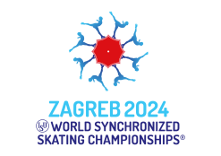
MEAL SERVICE
Please, fill in with type or write with capital letters
ISU Member:
Name of the Team:
Reference E-mail:
Team Leader:
Team Manager:
35,00 EUR per meal in ZONAR ZAGREB HOTEL (full meal buffet style)
35,00 EUR per meal in HOTEL INTERNATIONAL (full meal buffet style)
MEALS ORDER FORM
Date |  | Day | Meal | ZONAR ZAGREB |  | INTERNATIONAL
April 1, 2024 |  | Monday | Lunch
 |  |  | Dinner
April 2, 2024 |  | Tuesday | Lunch
 |  |  | Dinner
April 3, 2024 |  | Wednesday | Lunch
 |  |  | Dinner
April 4, 2024 |  | Thursday | Lunch
 |  |  | Dinner
April 5, 2024 |  | Friday | Lunch
 |  |  | Dinner
April 6, 2024 |  | Saturday | Lunch
 |  |  | Dinner
April 7, 2024 |  | Sunday | Lunch
 |  |  | Dinner
 |  |  | TOTAL MEALS:
 |  |  | PRICE for ticket: | 35,00 € |  | 35,00 €
 |  |  | TOTAL in EUR: | € |  | €

Return to:
Organizing Committee
Croatian Skating Federation, Trg K. Cosica 11, HR-10000 Zagreb, Croatia
E-mail: wsysc2024@croskate.hr

